Social_Capital Mediation Analysis

Wesley_Tao [wt2271@columbia.edu](mailto:wt2271@columbia.edu) 9176558355

2018/5/12

Mediation Analysis

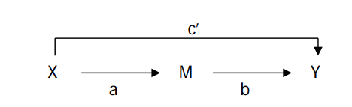

|  |  |  |
| --- | --- | --- |
| Treatment Variable | Mediation variable | Response Variable |
| X | M | Y |
| Jim Crow | Gini Coeficient | Socail Captial index |

# 1. Preprocessing and Data Engineering

library("xlsx")   
library(dplyr)  
library(Amelia)

## Warning: package 'Amelia' was built under R version 3.4.4

library(ggplot2)  
library("mediation")

## Warning: package 'mediation' was built under R version 3.4.4

## Warning: package 'sandwich' was built under R version 3.4.4

library(dplyr)  
library(psych)

## Warning: package 'psych' was built under R version 3.4.4

### 1.1 load and merge

# load the data  
table_1997<-read.xlsx("../data/social capital 1997-2014.xlsx", 1)  
table_2005<-read.xlsx("../data/social capital 1997-2014.xlsx", 2)  
table_2009<-read.xlsx("../data/social capital 1997-2014.xlsx", 3)  
table_2014<-read.xlsx("../data/social capital 1997-2014.xlsx", 4)  
# change the header so we could align dataframe  
names(table_2014)<-c("fips","areaname","sk14")  
  
m.1<-table_1997 %>%   
 full_join(table_2005, by = c("fips","areaname")) %>%  
 dplyr::select(everything())  
  
m.2<-table_2009 %>%   
 full_join(table_2014, by = c("fips")) %>%  
 dplyr::select(fips,sk09,sk14)  
  
merged<-m.1 %>%  
 full_join(m.2, by = c("fips"))%>%  
 dplyr::select(everything())  
  
all_content = readLines("../data/Gini coefficient 2010-2014.csv")  
skip_second = all_content[-2]  
Gini_coe = read.csv(textConnection(skip_second), header = TRUE, stringsAsFactors = FALSE)  
  
names(merged)[1]<-c("GEO.id2")  
merged<-merged %>%   
 full_join(Gini_coe, by = c("GEO.id2")) %>%  
 dplyr::select(GEO.id2, sk97, sk05, sk09, sk14,GEO.display.label,HD01_VD01)  
summary(merged)

## GEO.id2 sk97 sk05 sk09   
## Min. : 1001 Min. :-4.3107 Min. :-3.9094 Min. :-3.9252   
## 1st Qu.:18177 1st Qu.:-0.9961 1st Qu.:-0.9364 1st Qu.:-0.8347   
## Median :29176 Median :-0.2337 Median :-0.2259 Median :-0.2204   
## Mean :30385 Mean : 0.0000 Mean : 0.0000 Mean : 0.0000   
## 3rd Qu.:45082 3rd Qu.: 0.7578 3rd Qu.: 0.7022 3rd Qu.: 0.5265   
## Max. :56045 Max. : 8.2406 Max. :14.2963 Max. :17.4405   
## NA's :36 NA's :36 NA's :36   
## sk14 GEO.display.label HD01_VD01   
## Min. :-3.183280 Length:3144 Min. :0.3346   
## 1st Qu.:-0.756780 Class :character 1st Qu.:0.4176   
## Median :-0.226120 Mode :character Median :0.4376   
## Mean :-0.000003 Mean :0.4402   
## 3rd Qu.: 0.477669 3rd Qu.:0.4609   
## Max. :21.808830 Max. :0.6519   
## NA's :3 NA's :2

### 1.2 treat missing data

missmap(merged)

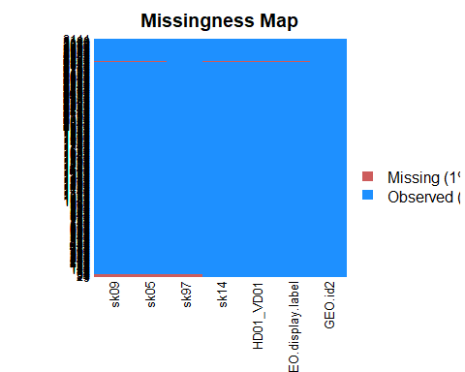

merged<-na.omit(merged) # remove NA

Since the missing values only account for a small proportion of the dataset. And it is not correlated with Y (dependent) and X variables (independent) We could safely delete them.

### 1.3 Jim_crow

n_row <-nrow(merged)  
list_1 <-strsplit(merged$GEO.display.label,split=",")  
State.County <-data.frame(matrix(unlist(list_1),nrow=n_row,byrow=T))  
colnames(State.County)<-c("County","State")  
merged<-cbind(merged,State.County)  
  
merged$State<-as.character(merged$State)  
merged$State<-substr(merged$State,2,nchar(merged$State))  
# add new independent variable   
Jim_Crow_States_list<-unlist(strsplit(" Alabama, Arizona, Arkansas, Delaware, Florida, Georgia, Kansas, Kentucky, Louisiana, Maryland, Mississippi, Missouri, New Mexico, North Carolina, Oklahoma, South Carolina, Tennessee, Texas, Virginia, West Virginia, Wyoming",","))  
Jim_Crow_States_list<-substr(Jim_Crow_States_list,2,nchar(Jim_Crow_States_list))  
Jim_Crow_States_list

## [1] "Alabama" "Arizona" "Arkansas" "Delaware"   
## [5] "Florida" "Georgia" "Kansas" "Kentucky"   
## [9] "Louisiana" "Maryland" "Mississippi" "Missouri"   
## [13] "New Mexico" "North Carolina" "Oklahoma" "South Carolina"  
## [17] "Tennessee" "Texas" "Virginia" "West Virginia"   
## [21] "Wyoming"

# add dummy variables Jim_Crow  
"Alabama" %in% Jim_Crow_States_list

## [1] TRUE

merged$Jim_Crow<-(merged$State %in% Jim_Crow_States_list)

# 2 Structural Mediation Regression analysis

## 2.1 Step 1 Regression M —> Y

Gini coefficient 2010-2014 –> on Social Capital 2014 (Social Capital is dependent variable)

names(merged)[7]<-"Gini_Coefficient"  
  
ggplot(data = merged)+  
 geom_smooth(aes(x=Gini_Coefficient,y=sk14))+ geom_point(aes(x=Gini_Coefficient,y=sk14))+  
 labs(title="Gini Coefficient and Social Capital Index")

## `geom_smooth()` using method = 'gam'

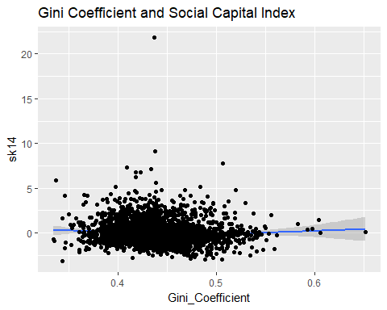

cat("the maximum value for social capital is ",merged$GEO.display.label[which.max(merged$sk14)])

## the maximum value for social capital is Edgefield County, South Carolina

cat("\nThis value is around the center of the data. In statistics, it wouldn't affect the model estimate very much. It was not a influential point.")

##   
## This value is around the center of the data. In statistics, it wouldn't affect the model estimate very much. It was not a influential point.

m1<-lm(sk14~Gini_Coefficient,data=merged)  
summary(m1)

##   
## Call:  
## lm(formula = sk14 ~ Gini_Coefficient, data = merged)  
##   
## Residuals:  
## Min 1Q Median 3Q Max   
## -3.5483 -0.7458 -0.2072 0.4641 21.7892   
##   
## Coefficients:  
## Estimate Std. Error t value Pr(>|t|)   
## (Intercept) 1.6318 0.2888 5.650 1.74e-08 ***  
## Gini_Coefficient -3.6900 0.6536 -5.646 1.79e-08 ***  
## ---  
## Signif. codes: 0 '***' 0.001 '**' 0.01 '*' 0.05 '.' 0.1 ' ' 1  
##   
## Residual standard error: 1.255 on 3104 degrees of freedom  
## Multiple R-squared: 0.01016, Adjusted R-squared: 0.009846   
## F-statistic: 31.88 on 1 and 3104 DF, p-value: 1.791e-08

## 2.2 step2 X—->M

1. States with Jim Crow Law are = 1, states without Jim Crow Laws are = 0.

ggplot(data =merged)+  
 geom_boxplot(aes(x=Jim_Crow,y=Gini_Coefficient))+   
 labs(title="Jim_Crow and Gini_Coe ")

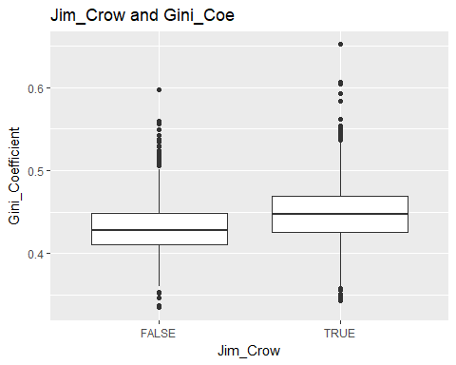

ggplot(data=merged,aes(x=Gini_Coefficient,color=Jim_Crow))+  
 geom_density()+  
 labs(title="Gini Coefficient Density by Jim_Crow")

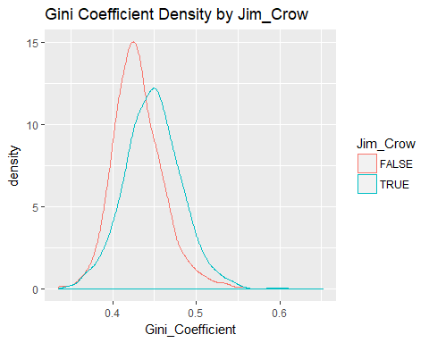

cat("summary statistics of gini coefficient by group")

## summary statistics of gini coefficient by group

describeBy(merged$Gini_Coefficient,list(jim_crow=merged$Jim_Crow))

##   
## Descriptive statistics by group   
## jim_crow: FALSE  
## vars n mean sd median trimmed mad min max range skew kurtosis se  
## X1 1 1395 0.43 0.03 0.43 0.43 0.03 0.33 0.6 0.26 0.67 1.6 0  
## --------------------------------------------------------   
## jim_crow: TRUE  
## vars n mean sd median trimmed mad min max range skew kurtosis  
## X1 1 1711 0.45 0.04 0.45 0.45 0.03 0.34 0.65 0.31 0.32 1.23  
## se  
## X1 0

1. Regression Jim Crow Laws –> on Gini coefficient 2010-2014

med.fit<-lm(Gini_Coefficient~Jim_Crow,data=merged)  
summary(med.fit)

##   
## Call:  
## lm(formula = Gini_Coefficient ~ Jim_Crow, data = merged)  
##   
## Residuals:  
## Min 1Q Median 3Q Max   
## -0.105169 -0.021469 -0.001669 0.019711 0.203431   
##   
## Coefficients:  
## Estimate Std. Error t value Pr(>|t|)   
## (Intercept) 0.4307495 0.0008921 482.87 <2e-16 ***  
## Jim_CrowTRUE 0.0177197 0.0012019 14.74 <2e-16 ***  
## ---  
## Signif. codes: 0 '***' 0.001 '**' 0.01 '*' 0.05 '.' 0.1 ' ' 1  
##   
## Residual standard error: 0.03332 on 3104 degrees of freedom  
## Multiple R-squared: 0.06544, Adjusted R-squared: 0.06514   
## F-statistic: 217.4 on 1 and 3104 DF, p-value: < 2.2e-16

## 2.3 step3 X—->Y

1. Regression Jim Crow Laws –> social capital 1997, 2005, 2009, 2014 (do for each year separately)

ggplot(data=merged,aes(x=sk14,color=Jim_Crow))+  
 geom_density()+  
 labs(title="2014 County Level Social Capital Density by Jim_Crow")+  
 xlim(-5, 10)

## Warning: Removed 1 rows containing non-finite values (stat_density).

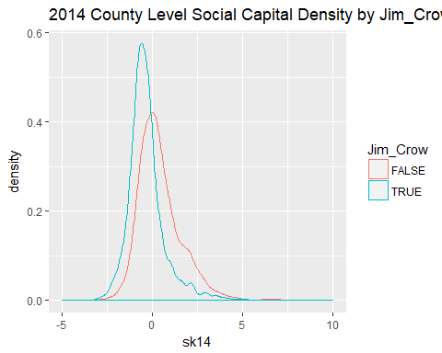

cat("summary statistics of 2014 social capital index by group")

## summary statistics of 2014 social capital index by group

describeBy(merged$sk14,list(jim_crow=merged$Jim_Crow))

##   
## Descriptive statistics by group   
## jim_crow: FALSE  
## vars n mean sd median trimmed mad min max range skew kurtosis  
## X1 1 1395 0.4 1.23 0.19 0.29 1 -2.95 9.15 12.1 1.35 4.15  
## se  
## X1 0.03  
## --------------------------------------------------------   
## jim_crow: TRUE  
## vars n mean sd median trimmed mad min max range skew  
## X1 1 1711 -0.32 1.19 -0.48 -0.44 0.69 -3.18 21.81 24.99 4.96  
## kurtosis se  
## X1 72.25 0.03

#### year 1999

summary(lm(sk97~Jim_Crow,data=merged))

##   
## Call:  
## lm(formula = sk97 ~ Jim_Crow, data = merged)  
##   
## Residuals:  
## Min 1Q Median 3Q Max   
## -3.7466 -0.8196 -0.2151 0.5571 7.5504   
##   
## Coefficients:  
## Estimate Std. Error t value Pr(>|t|)   
## (Intercept) 0.69023 0.03463 19.93 <2e-16 ***  
## Jim_CrowTRUE -1.25434 0.04665 -26.89 <2e-16 ***  
## ---  
## Signif. codes: 0 '***' 0.001 '**' 0.01 '*' 0.05 '.' 0.1 ' ' 1  
##   
## Residual standard error: 1.293 on 3104 degrees of freedom  
## Multiple R-squared: 0.1889, Adjusted R-squared: 0.1886   
## F-statistic: 722.9 on 1 and 3104 DF, p-value: < 2.2e-16

#### year 2005

summary(lm(sk05~Jim_Crow,data=merged))

##   
## Call:  
## lm(formula = sk05 ~ Jim_Crow, data = merged)  
##   
## Residuals:  
## Min 1Q Median 3Q Max   
## -3.6864 -0.7663 -0.1879 0.5501 14.8031   
##   
## Coefficients:  
## Estimate Std. Error t value Pr(>|t|)   
## (Intercept) 0.61999 0.03411 18.18 <2e-16 ***  
## Jim_CrowTRUE -1.12685 0.04596 -24.52 <2e-16 ***  
## ---  
## Signif. codes: 0 '***' 0.001 '**' 0.01 '*' 0.05 '.' 0.1 ' ' 1  
##   
## Residual standard error: 1.274 on 3104 degrees of freedom  
## Multiple R-squared: 0.1623, Adjusted R-squared: 0.162   
## F-statistic: 601.2 on 1 and 3104 DF, p-value: < 2.2e-16

#### year 2009

summary(lm(sk09~Jim_Crow,data=merged))

##   
## Call:  
## lm(formula = sk09 ~ Jim_Crow, data = merged)  
##   
## Residuals:  
## Min 1Q Median 3Q Max   
## -3.5520 -0.7559 -0.2011 0.4926 17.8138   
##   
## Coefficients:  
## Estimate Std. Error t value Pr(>|t|)   
## (Intercept) 0.45907 0.03408 13.47 <2e-16 ***  
## Jim_CrowTRUE -0.83234 0.04591 -18.13 <2e-16 ***  
## ---  
## Signif. codes: 0 '***' 0.001 '**' 0.01 '*' 0.05 '.' 0.1 ' ' 1  
##   
## Residual standard error: 1.273 on 3104 degrees of freedom  
## Multiple R-squared: 0.09574, Adjusted R-squared: 0.09544   
## F-statistic: 328.6 on 1 and 3104 DF, p-value: < 2.2e-16

#### year 2014

summary(lm(sk14~Jim_Crow,data=merged))

##   
## Call:  
## lm(formula = sk14 ~ Jim_Crow, data = merged)  
##   
## Residuals:  
## Min 1Q Median 3Q Max   
## -3.3573 -0.6947 -0.1905 0.4149 22.1271   
##   
## Coefficients:  
## Estimate Std. Error t value Pr(>|t|)   
## (Intercept) 0.40433 0.03237 12.49 <2e-16 ***  
## Jim_CrowTRUE -0.72256 0.04362 -16.57 <2e-16 ***  
## ---  
## Signif. codes: 0 '***' 0.001 '**' 0.01 '*' 0.05 '.' 0.1 ' ' 1  
##   
## Residual standard error: 1.209 on 3104 degrees of freedom  
## Multiple R-squared: 0.08123, Adjusted R-squared: 0.08094   
## F-statistic: 274.4 on 1 and 3104 DF, p-value: < 2.2e-16

## step 4 all together

1. Regression Jim Crow Laws + Gini Coefficient –> Social Capital (2014)

out.fit<-lm(sk14~Jim_Crow+Gini_Coefficient,data=merged)  
summary(out.fit)

##   
## Call:  
## lm(formula = sk14 ~ Jim_Crow + Gini_Coefficient, data = merged)  
##   
## Residuals:  
## Min 1Q Median 3Q Max   
## -3.2751 -0.7033 -0.1946 0.4299 22.1144   
##   
## Coefficients:  
## Estimate Std. Error t value Pr(>|t|)   
## (Intercept) 0.8751 0.2823 3.100 0.00196 **   
## Jim_CrowTRUE -0.7032 0.0451 -15.590 < 2e-16 ***  
## Gini_Coefficient -1.0930 0.6512 -1.679 0.09333 .   
## ---  
## Signif. codes: 0 '***' 0.001 '**' 0.01 '*' 0.05 '.' 0.1 ' ' 1  
##   
## Residual standard error: 1.209 on 3103 degrees of freedom  
## Multiple R-squared: 0.08207, Adjusted R-squared: 0.08148   
## F-statistic: 138.7 on 2 and 3103 DF, p-value: < 2.2e-16

# Mediation Analysis

1. Mediation analysis for Jim Crow Laws + Gini Coefficient –> Social Capital (2014)

med.out<-mediation::mediate(med.fit,out.fit,treat = "Jim_Crow",mediator = "Gini_Coefficient")  
summary(med.out)

##   
## Causal Mediation Analysis   
##   
## Quasi-Bayesian Confidence Intervals  
##   
## Estimate 95% CI Lower 95% CI Upper p-value   
## ACME -0.01936 -0.04199 0.00 0.076 .   
## ADE -0.70466 -0.79254 -0.62 <2e-16 ***  
## Total Effect -0.72402 -0.80915 -0.64 <2e-16 ***  
## Prop. Mediated 0.02695 -0.00209 0.06 0.076 .   
## ---  
## Signif. codes: 0 '***' 0.001 '**' 0.01 '*' 0.05 '.' 0.1 ' ' 1  
##   
## Sample Size Used: 3106   
##   
##   
## Simulations: 1000

This method is using simulation samples to construct the confidence interval for direct effect and mediate effect.

ADE stands for average direct effect

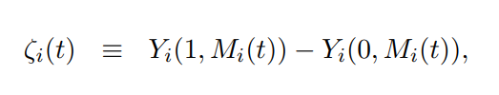

ACME means the average causal mediation effects

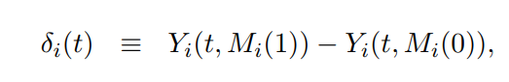

Total effect by definition:

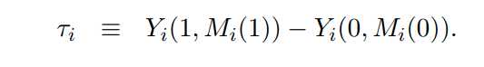

$$TotalEffect = Mediation Effect + DirectEffect$$

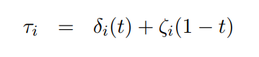

prop.mediated stands for the proportion of meidation effect. This is a ratio

$ prop.mediate = mediate.effect/direct.effect$

cat("Prop Mediated is a ratio of two estimates, which are known to have a very high variance especially when the average treatment effect is not precisely estimated.")

## Prop Mediated is a ratio of two estimates, which are known to have a very high variance especially when the average treatment effect is not precisely estimated.

cat(" I would focus on the point estimate of this quantity rather than its CI. The most important thing is the ACME which have a much more stable CI.")

## I would focus on the point estimate of this quantity rather than its CI. The most important thing is the ACME which have a much more stable CI.

plot(med.out)

